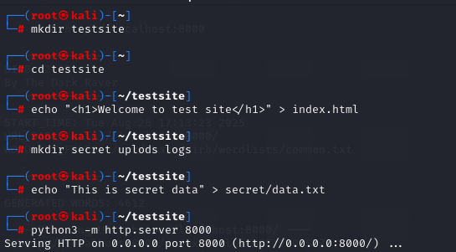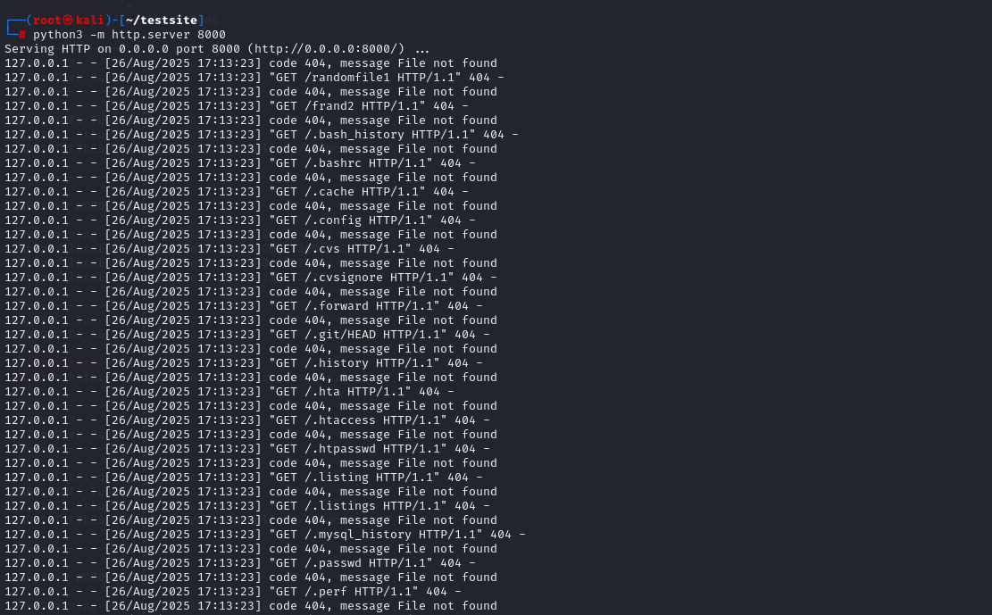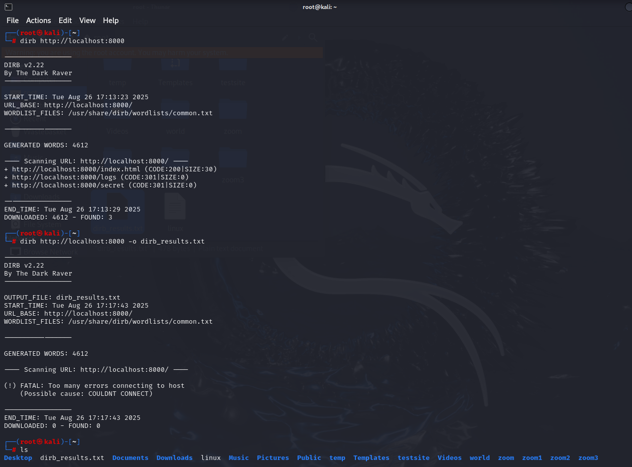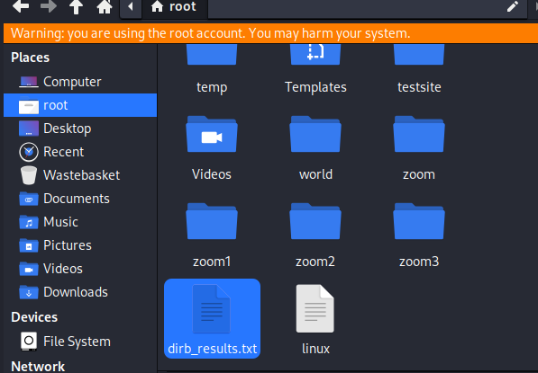

I used python server along with drib

Created a directory and added data into localhost 8000

Parallel I opened another terminal performed server scan using drib and used common wordlist

Generated a report.

C:\Users\Manaswini\Downloads\dirb_results.txt